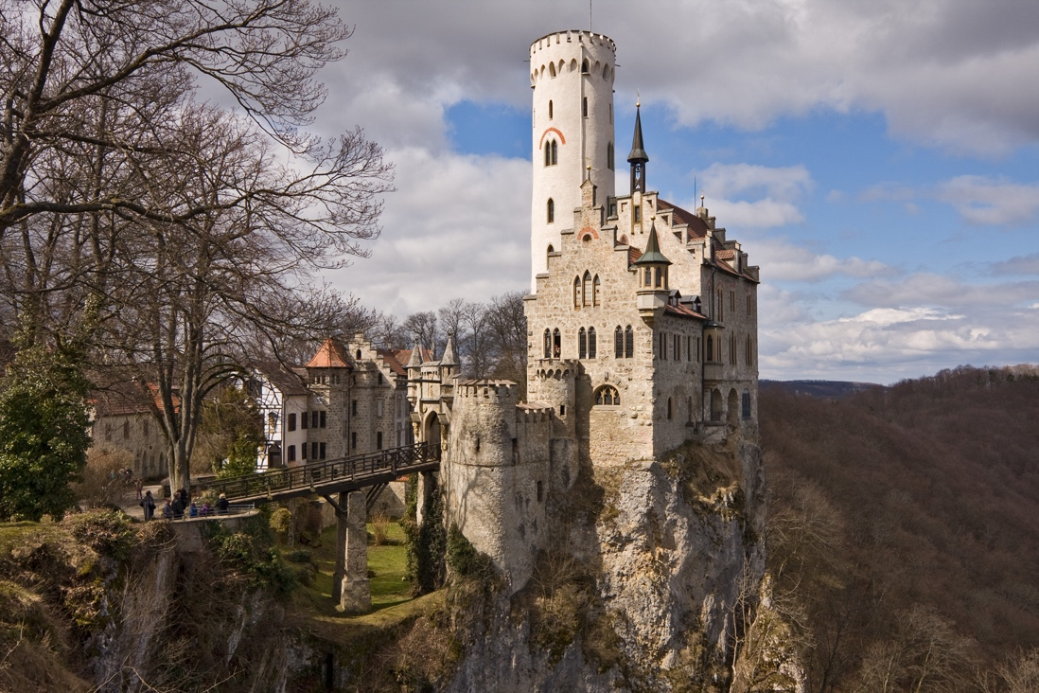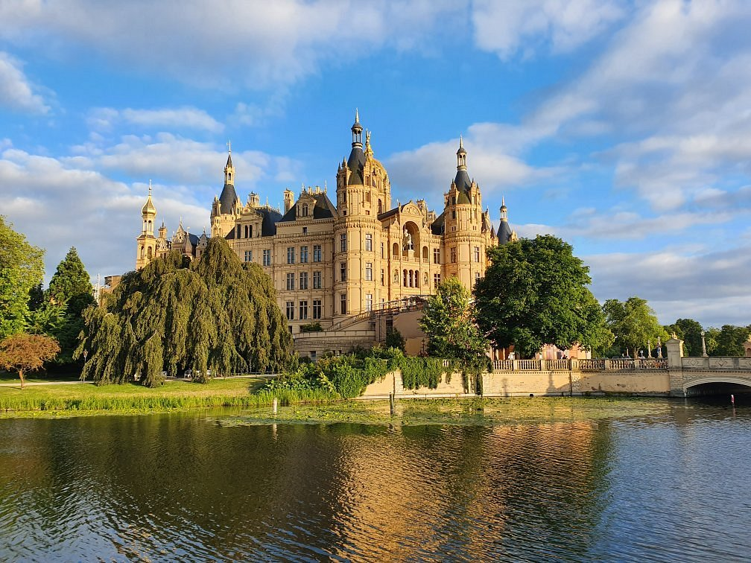\

Schloss Hohenschwangau

Schloss Schwerin

Schloss Lichtenstein

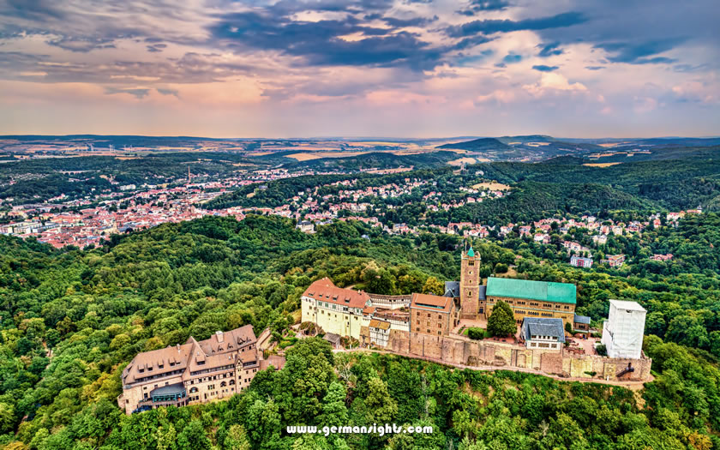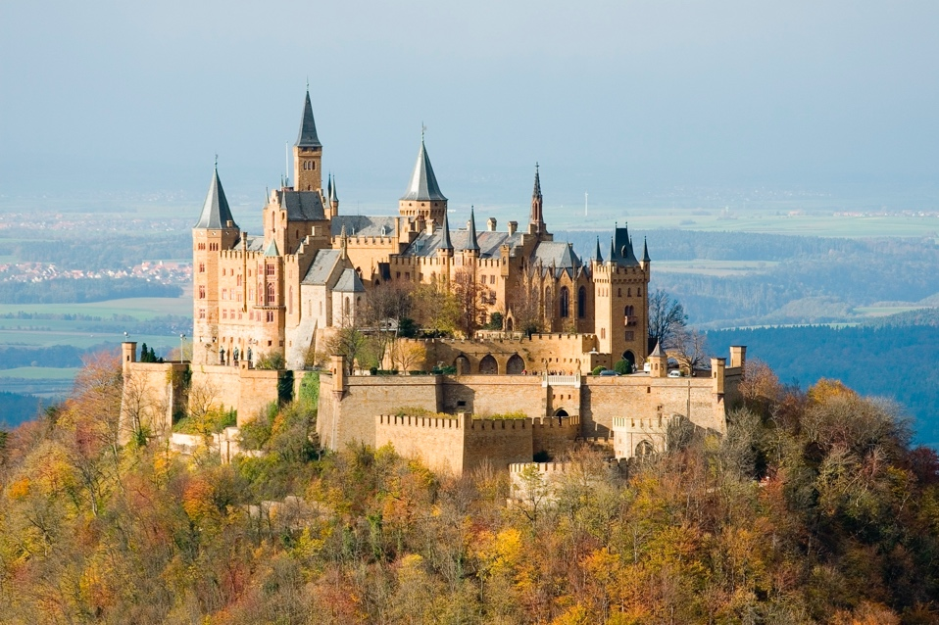

Wartburg

Burg Hohenzollern