Conversation Class Lesson Summary

Language Resident Name: Marina Simonnet

Day and Date: Wednesday, April 11

Language and Level (intermediate or advanced class): Advanced

Class theme/topics discussed: Using French in the context of “surrealism”, improvisation or argumentation.

Goal of the class:

How did you structure the class?

1. Warm-up: if you had to survive in a desert island, which are the three objects that you would like to have with you?
2. Role-play: a boat is about to go down. Each student is given a list of objects and has to convince each other that their list is better than the other ones.
3. Role-play: by pair, students play a couple that has divergent opinions on different topics and has to agree on a decision.
4. Role-play game with two teams and one “judge”: in a paradise, there are a judge and two “dead” people. Only one can enter the paradise. The judge picks one card and then the others have to find the best and worst action related to the topic of the card. The judge will choose who is the most convincing. We play this three times and then the winner becomes the judge.

What technology, media or props did you use? (internet resources, playmobiles, handouts, etc.)

What worked well in this class? What did not work?

The second activity was so intense that I actually had to stop in the middle and make anonymous votes to eliminate one group (they worked by pair to defend their list). People were very creative with the third activity too and I like asking the other students who they found more convincing to get them more involved.

How could this class be improved/ modified?

Because I have ten students, I only asked one object for the warm-up (otherwise it’s too long)

If you have a more detailed lesson plan, please attach it below (OK to use target language for that).

../../../Downloads/MJArgumBoxe.pdf

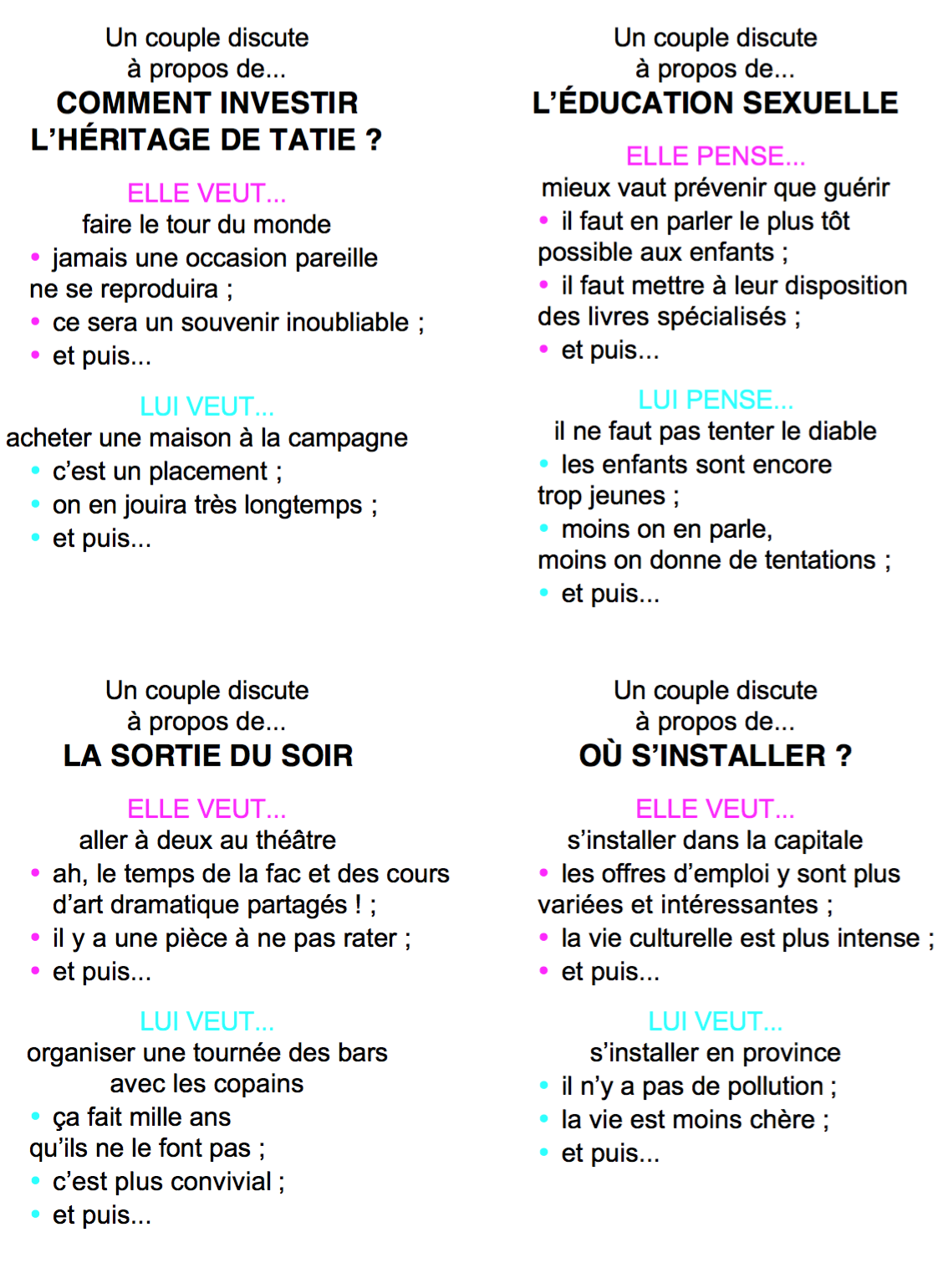

../../../Downloads/l'île%20déserte.pdf