Conversation Class Lesson Summary

Language Resident Name: Marina Simonnet

Day and Date: Thursday, March 29

Language and Level (intermediate or advanced class): French // Intermediate

Class theme/topics discussed: Human body

Goal of the class: Learn/review the vocabulary and expressions of human body.

How did you structure the class?

- We watch a video about expressions used with testicles and the students have to find them in the right order and match their definition (see handout).
- Pairwork with idiomatic expressions using body parts. The students have to find the definition of the idiomatic expressions.
- Dominos’ game with “diseases, wounds, infections” (see handout in the other .docx file)
- Role-play (pairwork) with doctor and patient.

What technology, media or props did you use? (internet resources, playmobiles, handouts, etc.)
https://www.youtube.com/watch?v=yJbd0GbLiKE

What worked well in this class? What did not work?
Everything worked fine: idiomatic expressions were a little bit difficult but it enhances the group work and the discussion between people so I wouldn’t change anything. It was good to give the students some autonomy and see how they solve the exercise.

How could this class be improved/ modified?
For the role-play, ask the students to add some idiomatic expressions they learnt too so the activity becomes even more efficient and coherent within the class.

If you have a more detailed lesson plan, please attach it below (OK to use target language for that). Please attach any handouts as well.

"Les couilles" - La langue française expliquée par un Américain

Une couille quelque part ♦

Se peler les couilles ♦

S’en battre les couilles ♦

Partir en couille ♦

Avoir les couilles molles ♦

Casser les couilles ♦

Avoir des couilles en or ♦

*

♦ Avoir froid

♦ Être riche

♦ Être foutu

♦ Énerver

♦ Être peureux/trouillard

♦ Un problème

♦ S’en ficher

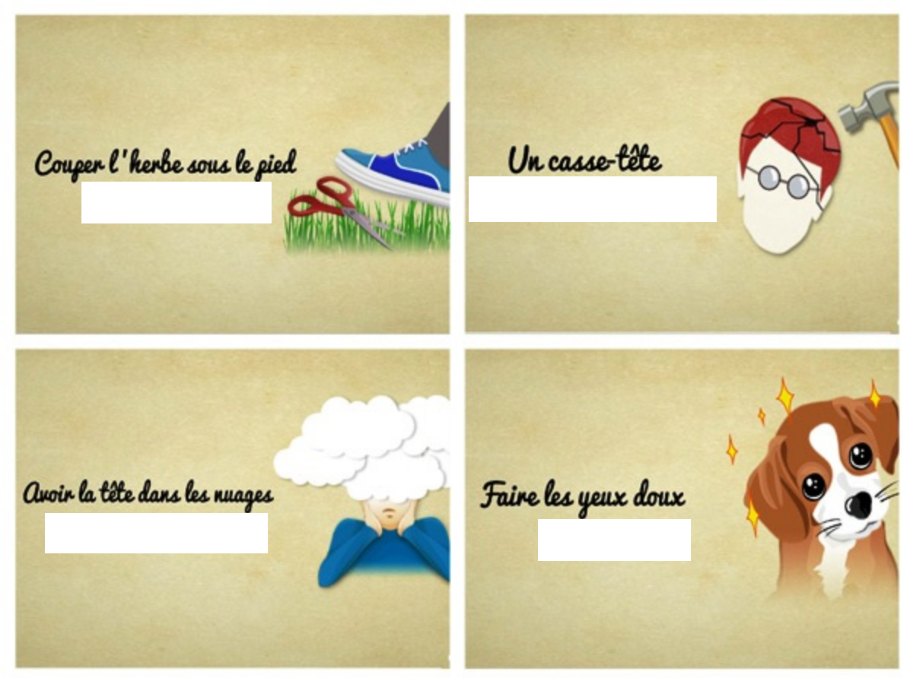
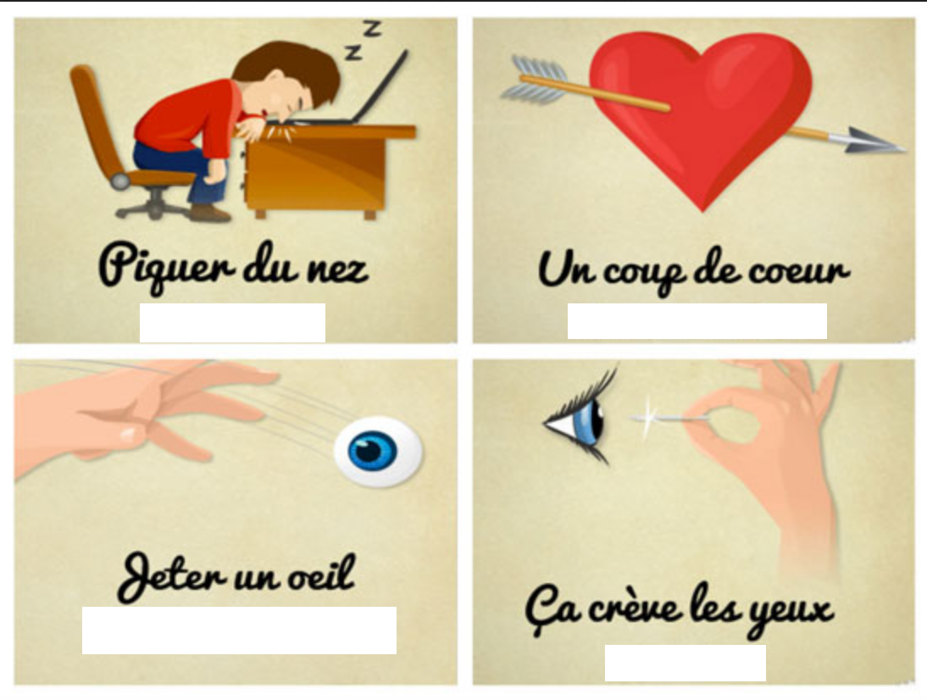
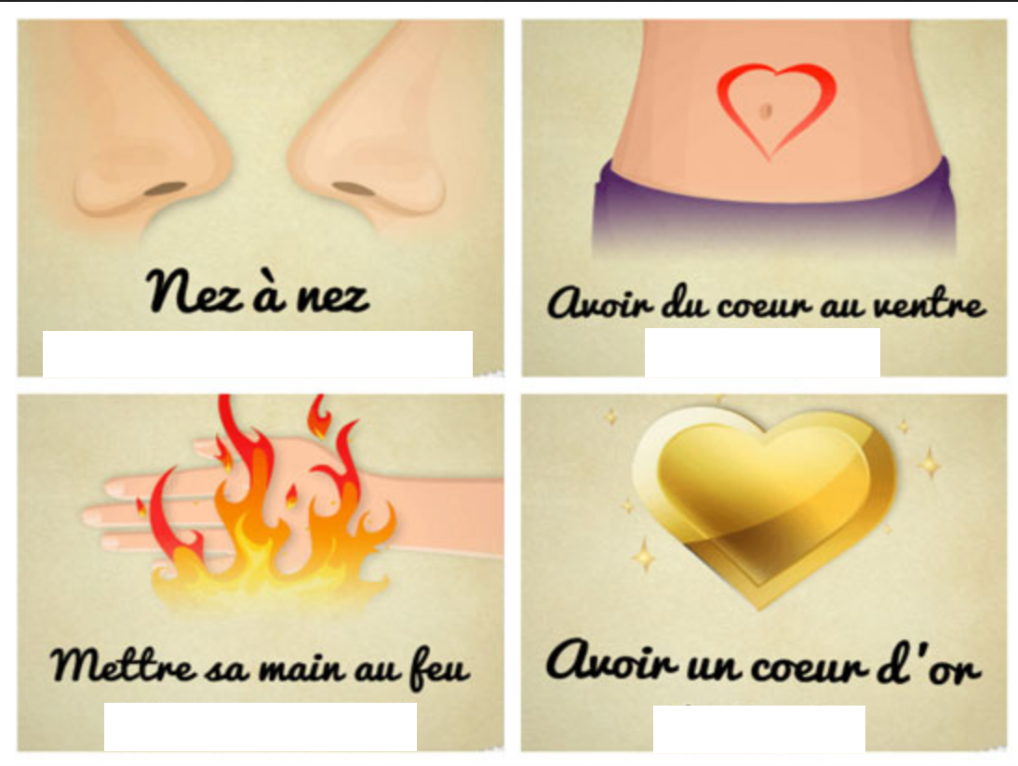
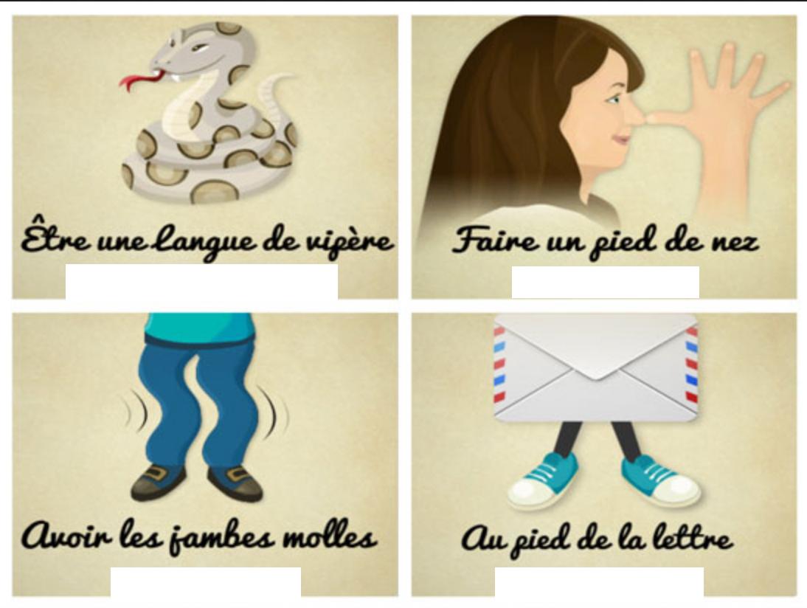
- Affirmer avec ferveur
- Aimer quelque chose soudainement
- Avoir des propos malveillants
- C’est évident
- Devancer quelqu’un
- Être courageux
- Être rêveur, distrait
- Être très gentil
- Prendre un propos au sens strict
- Regarder quelque chose
- Rencontrer quelqu’un par hasard
- Séduire
- Se moquer
- S’endormir
- Se sentir faible
- Un problème difficile à résoudre

