Conversation Class Lesson Summary

Language Resident Name: Marina Simonnet

Day and Date: Wednesday, November 1

Language and Level (intermediate or advanced class): Advanced Plus

Class theme/topics discussed: Music

Goal of the class: Learn about the vocabulary of music (music instruments, idiomatic expressions), practice of the listening comprehension part with songs, create a dialogue with specific vocabulary.

How did you structure the class?
- Warm-up: Introduce the “Fête de la Musique” and ask the students about their habits related to music (playing an instrument, favorite band, etc.). They’ll have a handout about habits of French people so we can make comparisons.
- We watch a video about the famous singer Stromae without the sound. I give the students ten words (that appear on the video), and they have to imagine the dialogue using them (“Radin ; Bignou ; Danser ; S’amuser ; Malade ; Chien ; Soif ; Canard ; S’extasier ; Désinvolte”). Then, we watch the video.
- I give the students a handout with titles of French songs: I will play songs extracts and just by listening to the extracts, the students have to guess what the song is.
- Idiomatic expressions with music: Multiple-choice questions on a handout

What technology, media or props did you use? (internet resources, playmobiles, handouts, etc.)

https://www.youtube.com/watch?v=LBf65mZVsCo

What worked well in this class? What did not work?

The main activities were very fun: the students also learnt new vocabulary! The activity with the songs was a bit experimental but the students told me they loved it and wanted another one.

How could this class be improved/ modified?

With less advanced students, the songs have to be easier to guess!

If you have a more detailed lesson plan, please attach it below (OK to use target language for that).
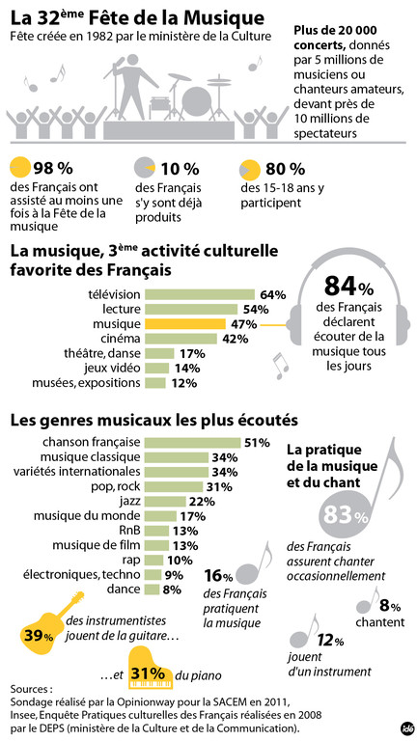

Blind test – Chanson française

Pink Martini – Sympathique -
Claude Nougaro – Dansez sur moi -
Paris Combo – Aquarium -
Coralie Clément – La samba de mon coeur qui bat -
Susie Arioli – Un jour de différence -
Bernard Lavilliers – Salomé -
Enzo Enzo – La chanson des jumelles -
Hocus Pocus – Place 54 -
M – Ma bonne étoile -
Dionysos – Tes lacets sont des fées (Avez-vous deviné le jeu de mot ?) -

Expressions idiomatiques sur la musique

Si un ami vous dit que vous chantez comme une casserole, ça signifie que :
- Que vous chantez faux
- Vous chantez en faisant la cuisine
- Vous avez une très belle voix
C'est dimanche. Vous êtes en train de dormir sur vos deux oreilles lorsque, soudain, la sonnette retentit. C'est un réveil en :
- Orchestre
- Fanfare
- Orgue
Parmi les trois mots ci-dessous, lequel peut être utilisé à la place de l'interjection “Zut !” pour marquer l'irritation et l'exaspération ?
- Violon
- Piano
- Flûte
Votre voisin ne cesse pas de vous raconter des potins. Vous en avez assez ! C'est toujours la même:
- Chanson
- Mélodie
- Ode

