Conversation Class Lesson Summary

Language Resident Name: Akihiro Shimizu

Day and Date: Monday, February 2nd. Tuesday, February 3rd.

Language and Level (intermediate or advanced class): Japanese, Intermediate

Class theme/topics discussed: Police Affaire

Goal of the class:
Students will be familiar with Japanese police matter.
Students will know new vocabularies concerning police.
Students will know how to speak to police when they lose their belongings.

How did you structure the class?
1. Advertisement
I advertised up-coming cultural activities.
2. Warm-up
I ask students about American police. Do you talk to police? When do you speak to police? How do you find them?
3. Vocabularies
I distribute a copy of handout. On it there are several vocabularies concerning police. They will be key words in case we talk to police. We check them one by one. If a student knows the meaning of a word, he/she explains it. Otherwise, I do instead of them.
4. Icebreaker
Give one picture sheet to each student. One student is a witness who saw a robbery, and the other is a police officer. The police officer asks the witness questions to find which man in the picture is the thief. When the police officer knows who the thief is. s/he tells the number for him to the witness and checks if it s correct.
5. Skit
On the backside of the handout is a skit. one act as a police and the other does a guy who lot his/her wallet. By reading the skit students practice how to ask police to look for his/her lost property.

What technology, media or props did you use? (internet resources, playmobiles, handouts, etc.)
handout

What worked well in this class? What did not work?

How could this class be improved/ modified?

If you have a more detailed lesson plan, please attach it below (OK to use target language for that). Please attach any handouts as well.

警察！

1. ボキャブラリー
おまわりさん、交番、犯人、目撃者、職質（職務質問）、紛失届、身分証明書

2. 犯人はだれ？
警察官: どんな髪型をしていましたか。
目撃者: いいえ。
警察官: めがねをかけていましたか。
目撃者：はい。

1 2 3 4 5
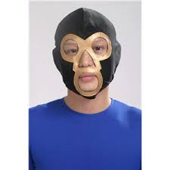
6 7 8 9 10
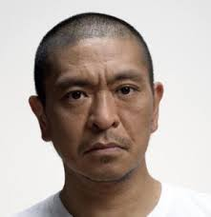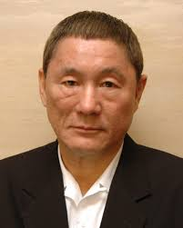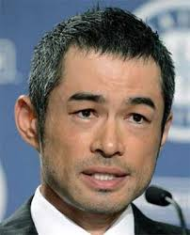

3. 次のものを失くしました。説明してください。

例）
あなた: あのう、すみません、携帯を落としてしまったんですけど。
警察官: どんな携帯ですか。
あなた: 。
警察官:どのへんで落としたかわかりますか。
あなた： 。
警察官: わかりました。では、見つかったら連絡しますから、この紛失届に住所と名前と電話番号を書いてください。
あなた: はい、わかりました。

1 2 3
