Conversation Class
Lesson Summary

Language and Section: Advanced

Date: September 26

Class theme/topics discussed: The tradition of Kimono in Japan

Goal of the class:

-To learn about the history and transition of Kimono
-To make students aware of the declining trends that kimono traditions are facing in modern day society

Structure of the class (unless you attach your lesson plan below):

(1st activity Learning about Kimono Culture)
-I shared my power point describing history of Kimono and we watched a youtube video of Kimono store owner’s speech about the history and decline of Kimono atched a youtube video of popularity of Kimono in America

(2nd activity Discussion)
-Discussed about beauty as well as issues of Kimono

(3rd activity Making project)
-Using my project outline, students worked in pairs to planed their projects to help restore Kimono tradition

What technology, media or props did you use? (satellite tv, internet resources, playmobiles, etc.)
TV, youtube , PowerPoint

What worked well in this class? What did not work?
They enjoyed working on their project and they learned a lot about how they can restore Kimono culture working in groups.

How could this class be improved/ modified?
I had difficulty working with the PowerPoint so if I practice it can go more smoothly next tim

Please attach your lesson plan and handouts for this class below – if you used any.

着物の伝統の伝統を守ろうプロジェクト

〜歴史の深い着物を世界に誇る民族衣装として残していくために〜

どんなプロジェクト？

プロジェクトに参加する人

何を使って（プロジェクトに必要なツール）

どんな場所で

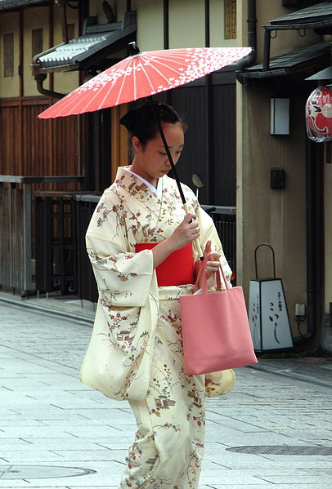
プロジェクトの具体的な内容
