Conversation Class
Lesson Summary

Language and Section: Intermediate

Date: November 5

Class theme/topics discussed: Kansai dialect in Japan

Goal of the class:

-Students will learn about Kansai dialect and know the difference between Kansai dialect and the standard language
-Students will learn about vocabulary and common phrases in Kansai dialect
-Students will be able to use Kansai dialect

Structure of the class (unless you attach your lesson plan below):

(1st activity Introduction)
-Students watched a youtube clip of “吉本新喜劇“which is a Japanese comedyans the teacher asked the students what words or phrases they heard in the clip
-Teacher taught the students about the background of Kansai dialect, such as in which areas Kansai dialect is spoken
-Teacher taught the students about characteristics of intonations and accents of Kansai dialect
-Students rehearsed a short script written in the standard language and the students listened to a recording of a short script in Kansai dialect

(2nd activity Reharsing Kansai dialect)
-Students rehearsed the short script written in Kansai dialect
-Teacher taught the students some distinctive Kansai dialect vocabulary such as:“おおきに” or ”なんぼ.
-Students practiced speaking Kansai dialect in pairs using the script.

(3rd activity Making-up the stories)
-Students made short original stories using Kansai dialect in pairs and students shared their original stories with the class.

(4th activity conclusion)
-Students discussed about what they think about Kansai dialect (Is it strange? Is it interesting?)

What technology, media or props did you use? (satellite tv, internet resources, playmobiles, etc.)

Handout, whiteboard, map of Japan,
YouTube clip (https://www.youtube.com/watch?v=ljDlDT59vns)

What worked well in this class? What did not work?

Students enjoyed watching the Japanese comedy, and they were also able to catch the words and phrases of Kansai dialect spoken in the YouTube clip. The YouTube video successfully stimulated their motivation to learn Kansai dialect. I did not expect them to be able make their own original short stories using Kansai dialect, but they used a lot of Kansai dialect that we went over in class. They were entirely engaged in the class.

How could this class be improved/ modified?
I chose a YouTube video where the cast spoke a little bit too fast so the students struggled to catch the words and phrases when they watched the video. I should have chosen a video where the cast spoke more slowly.

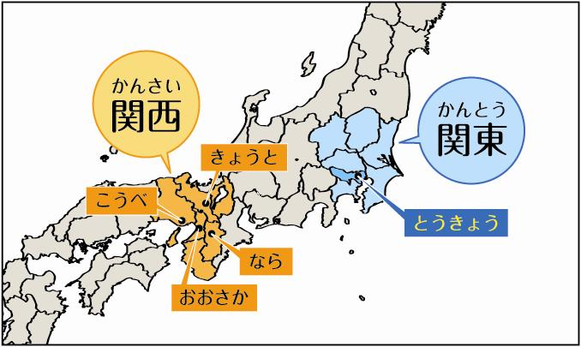
Please attach your lesson plan and handouts for this class below – if you used any.

