Conversation Class Lesson Summary

Language Resident Name: Marina Simonnet

Day and Date: Thursday, September 14

Language and Level (intermediate or advanced class): French // Intermediate

Class theme/topics discussed: Art (Journées du Patrimoine 2017) //class at the FLRC

Goal of the class: Learn about art in France (Journées du patrimoine 2017) and create their own story using works of art from French museums (PowerPoint Karaoke)

How did you structure the class?
- Warm-up: We play a game called “Memory” (students have to match two identical images together). I think it could help build the vocabulary about art.
- Pairwork: Using the RMN website, the students have to create a powerpoint telling a story. The topic will be free because they’re intermediate and the exercise might be already a little difficult for them. I will focus on how they interact with each other.
- Powerpoint Karaoke: Once they’re done, they will have to give their powerpoint presentation to another group who will have to improvise and invent a story depending on what they see. Then, the initial group who created the Powerpoint will tell us the “real story” behind what they created. We might not have time to do both parts.

What technology, media or props did you use? (internet resources, playmobiles, handouts, etc.)
Réunion des Musées Nationaux :
http://www.photo.rmn.fr/C.aspx?VP3=SearchResult&ALID=2CO5S9IZDCBN
A memory game (see below)

What worked well in this class? What did not work?
The memory was a good activity, but not so much a warm-up (we spent almost 25 minutes on it). The exercise was interesting because they really had to remember the words itself (and not only the image) to match the pairs. We didn’t have time to make the third activity but it’s okay: the second activity worked really fine and the participation was balanced between each member of each group.

How could this class be improved/ modified?

If you have a more detailed lesson plan, please attach it below (OK to use target language for that). Please attach any handouts as well.

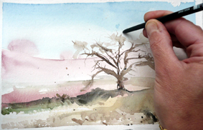  L’aquarelle (technique) | 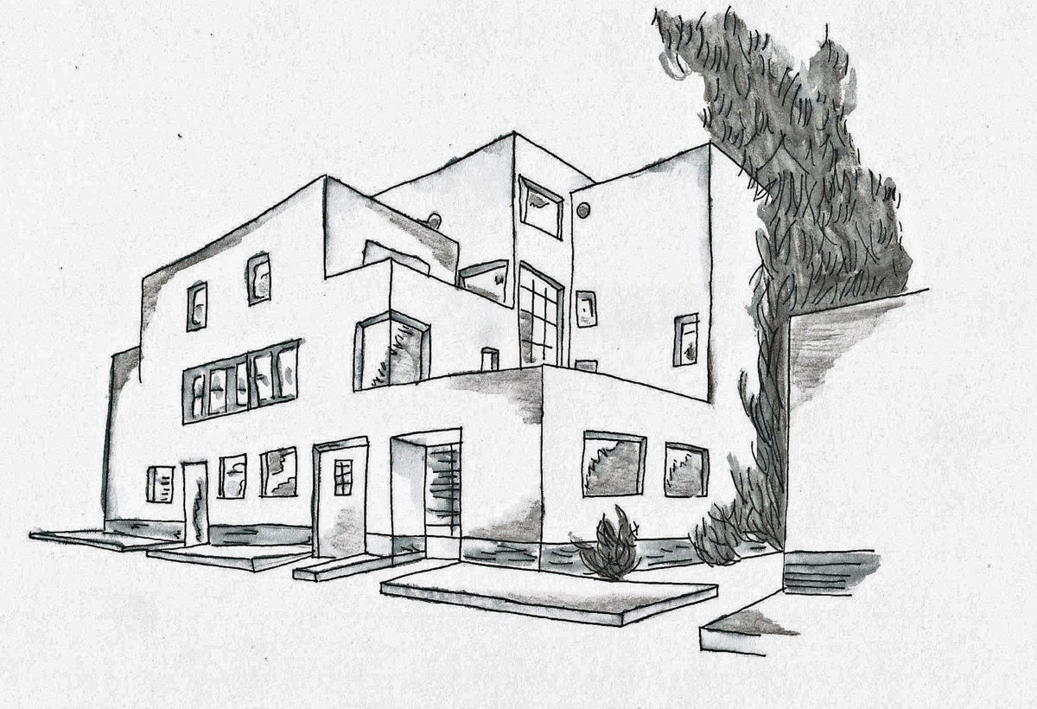  L’architecture (technique) | 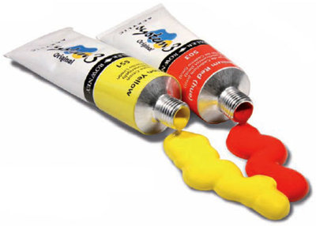La peinture (objet)
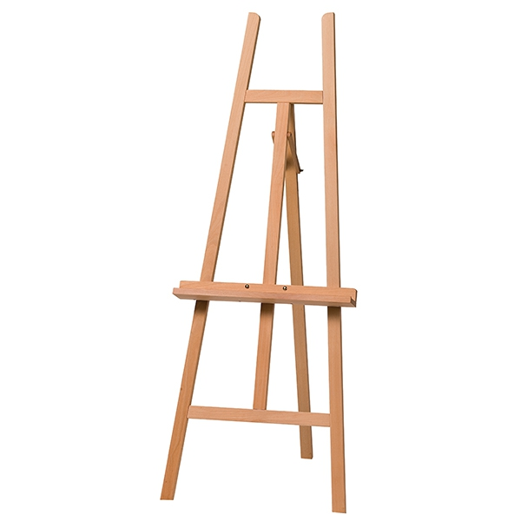  Le chevalet (objet) | 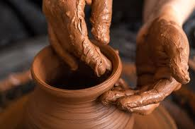  La poterie (technique) | 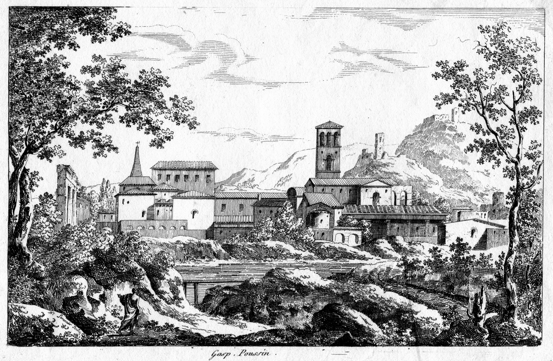  La gravure (technique)
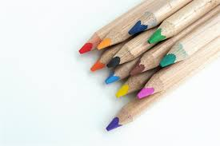  Les crayons de couleurs (objet) | 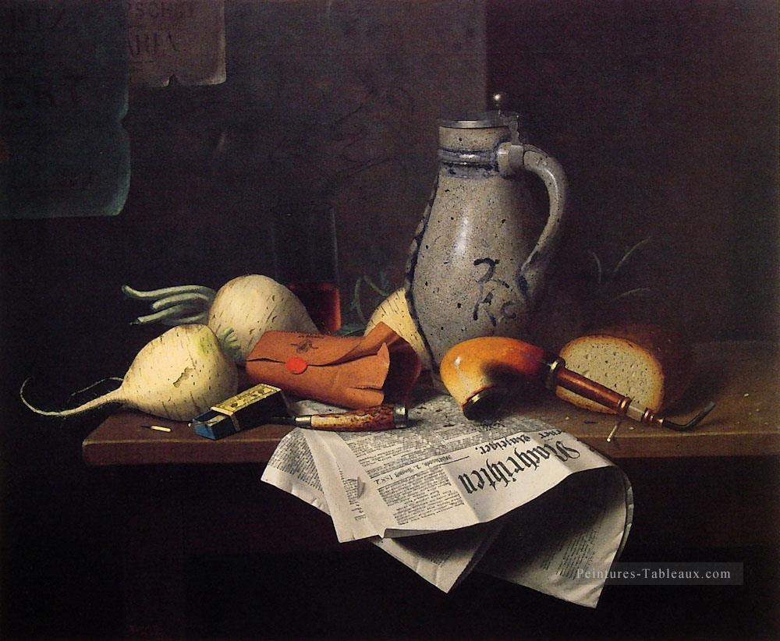  La nature morte (genre) | 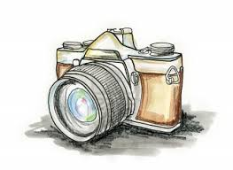  L’appareil photo (objet) / La photographie (technique)
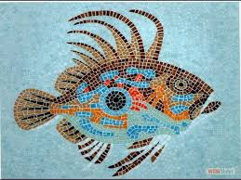  La mosaïque (objet et technique) | 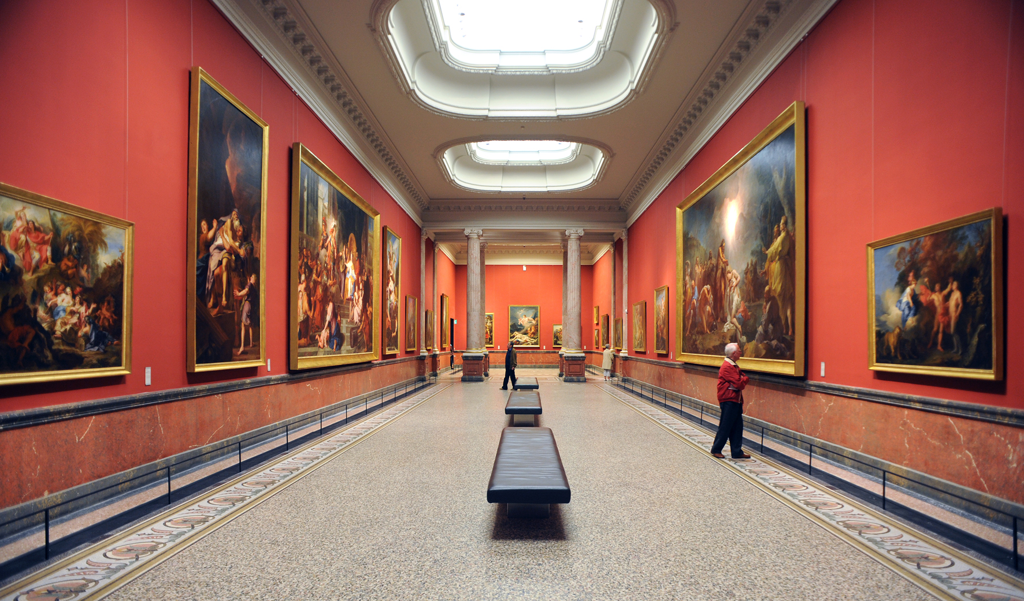  Le musée (lieu) | Le cadre (objet)

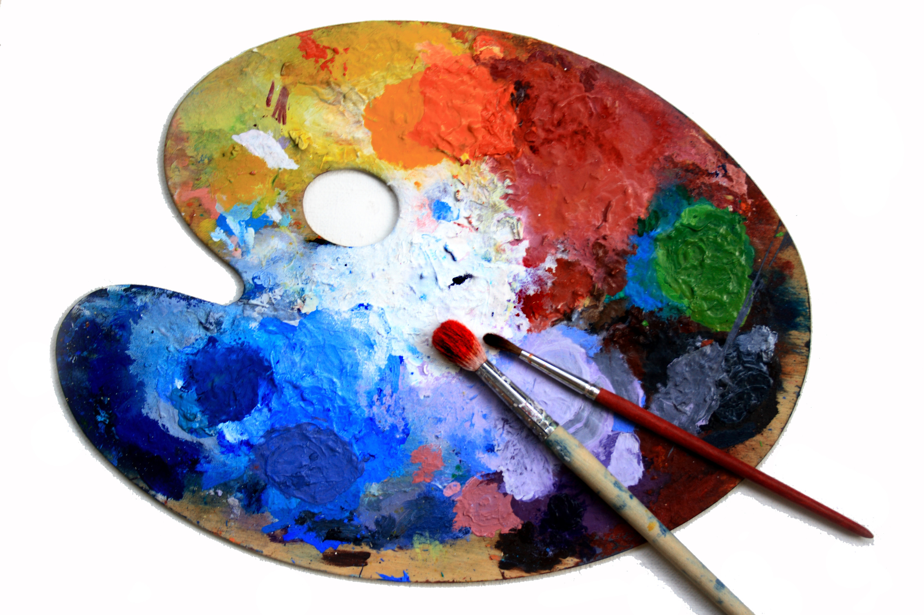  La palette (objet) | 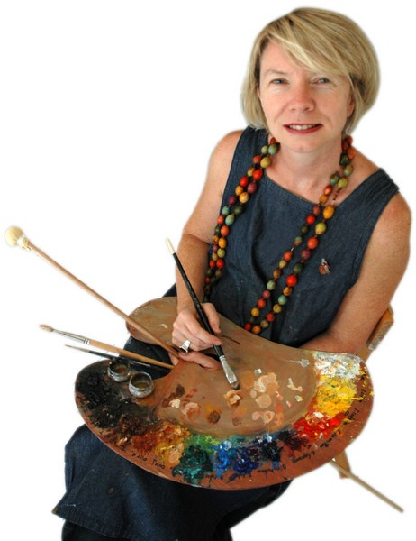  Le peintre (artiste) | 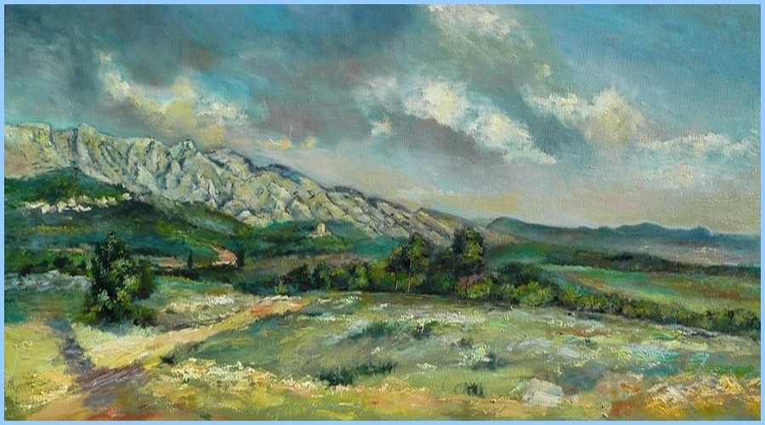  Le paysage (genre)
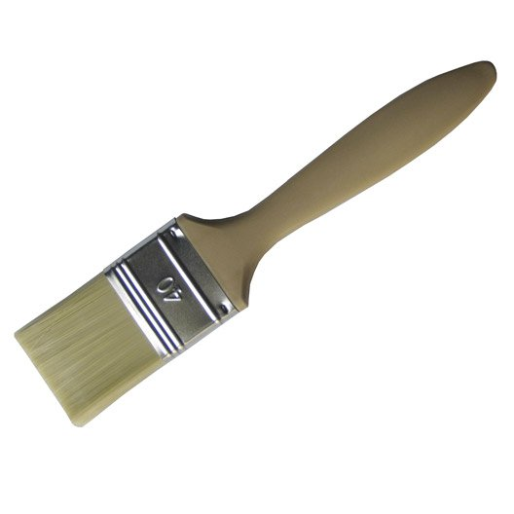  Le pinceau (objet) | 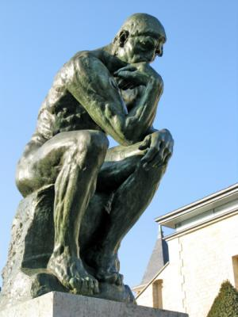  La sculpture (technique) | 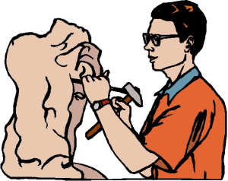  Le sculpteur (artiste)
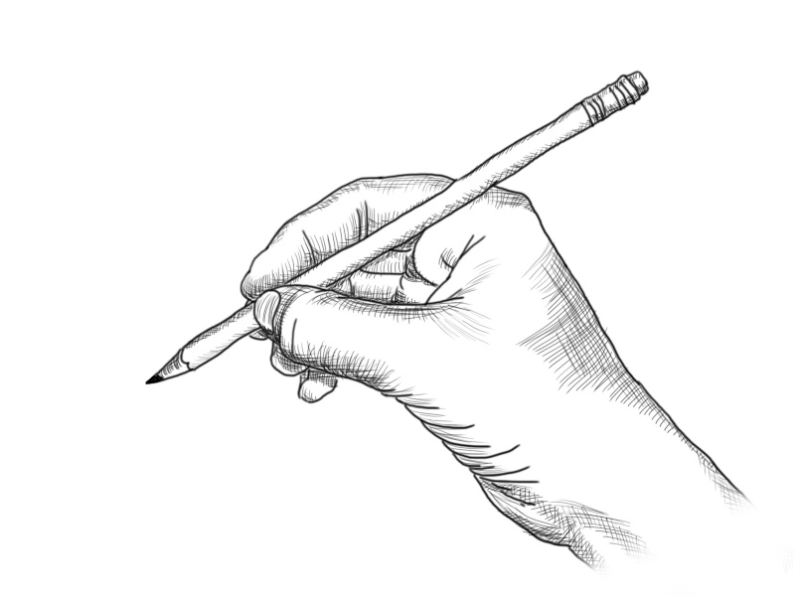  Le dessin (technique) | 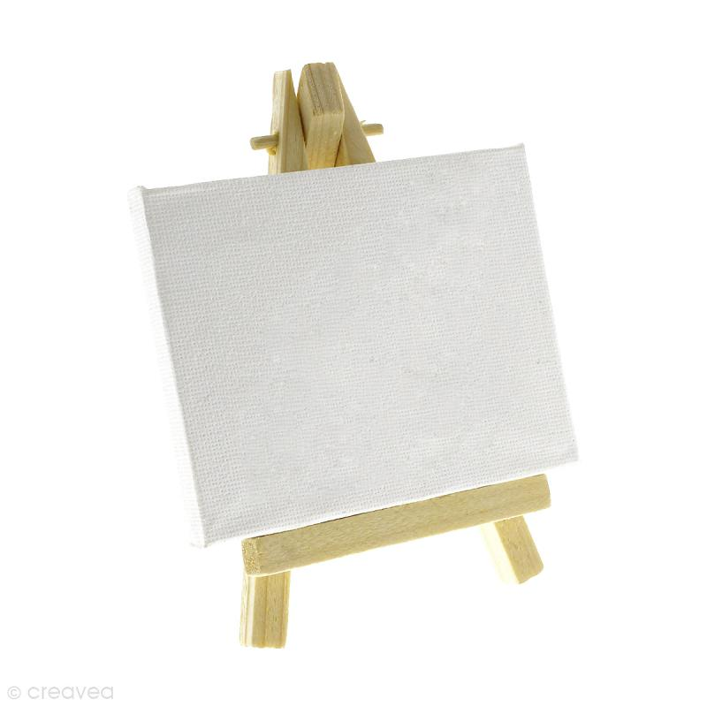  La toile (objet) | 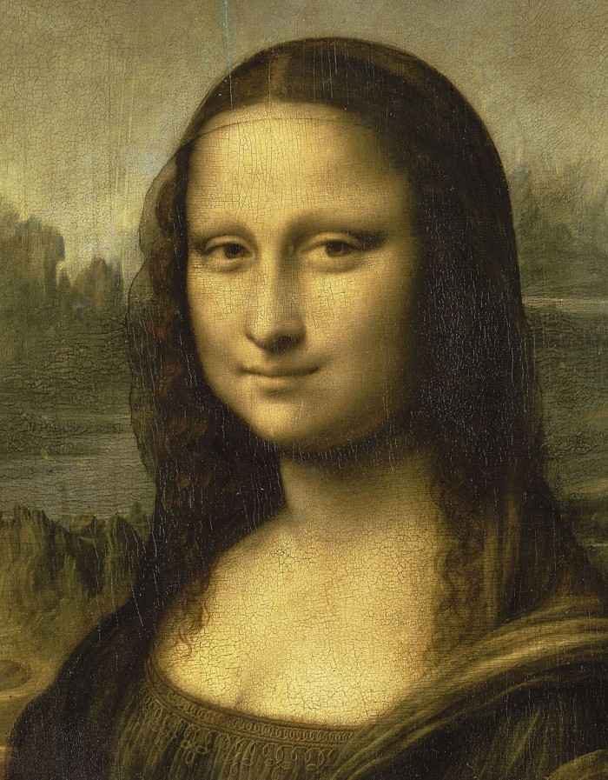  Le portrait (genre)
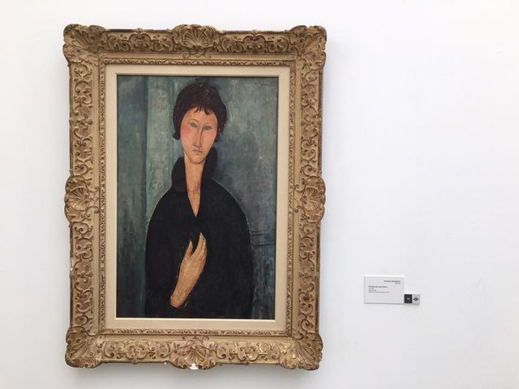  Le tableau (objet) | 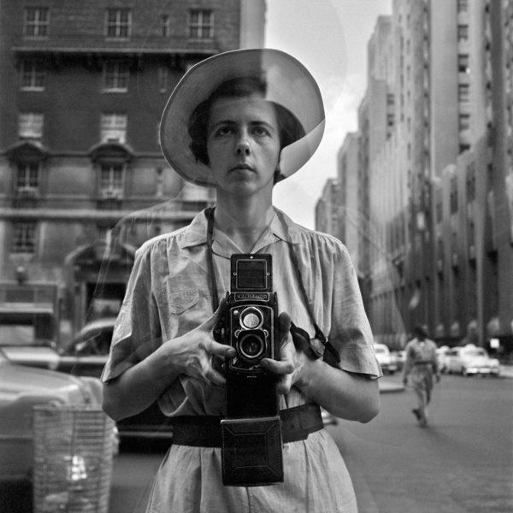  L’autoportrait (genre) | 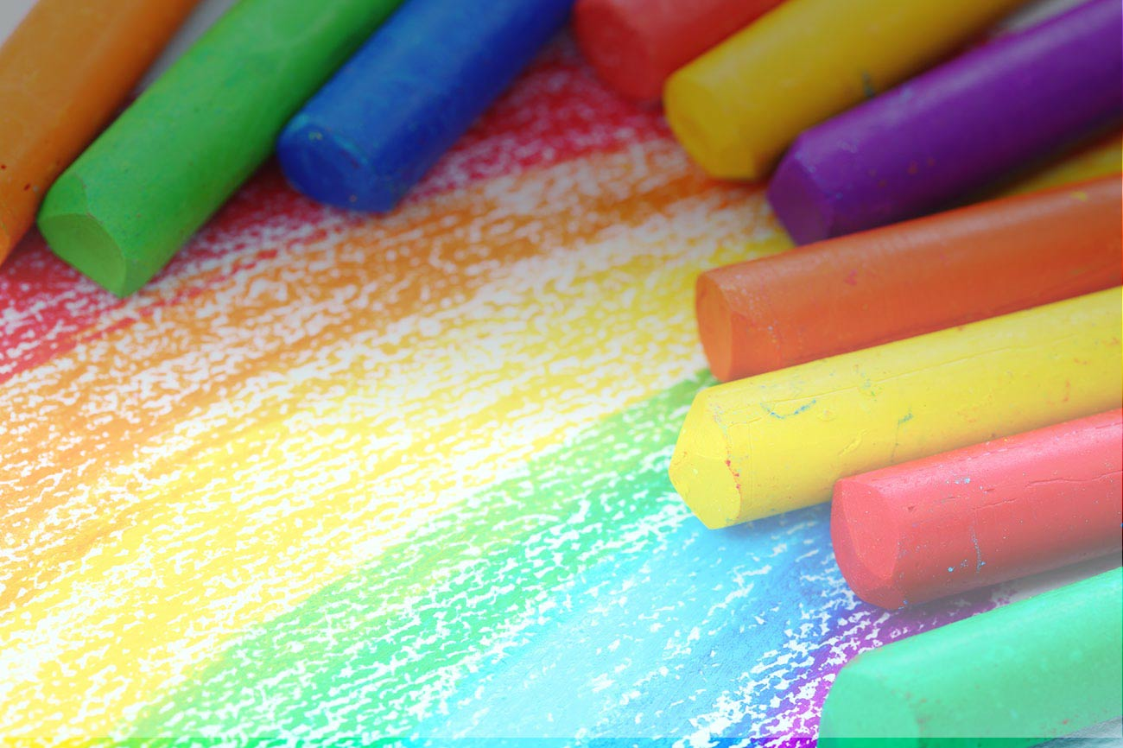  Le pastel (technique)

L’aquarelle (technique) | L’architecture (technique) | La peinture (objet)
Le chevalet (objet) | La poterie (technique) | La gravure (technique)
Les crayons de couleurs (objet) | La nature morte (genre) | L’appareil photo (objet) / La photographie (technique)
La mosaïque (objet et technique) | Le musée (lieu) | Le cadre (objet)

La palette (objet) | Le peintre (artiste) | Le paysage (genre)
Le pinceau (objet) | La sculpture (technique) | Le sculpteur (artiste)
Le dessin (technique) | La toile (objet) | Le portrait (genre)
Le tableau (objet) | L’autoportrait (genre) | Le pastel (technique)

