Conversation Class Lesson Summary

Language Resident Name: Tatiana Ermolaeva

Day and Date: Wednesday, 02/17/2016

Language and Level (intermediate or advanced class): Russian, Intermediate

Class theme/topics discussed:

Goal of the class:

How did you structure the class?
1. Warm up.
Every student has a picture. The task is to find a student who has a similar (pair) picture by asking questions but not naming the object on the picture. When they think they found their pairing picture they explain to the class why the think they pair and show their pictures to the class simultaneously to find out whether they were right or not.
15 minutes
2. Watch a cartoon “Bremenskie muzikanty” https://www.youtube.com/watch?v=3-HBgvJL5rI
Answer the questions:
Who is there in the cartoon?
Where the musicians are going? What are they doing in the castle? What is happening next?
30 minutes
3. Fill in the missing words from the song.
10 minutes

What technology, media or props did you use? (internet resources, playmobiles, handouts, etc.)
Laptop, TV, internet, handouts

What worked well in this class? What did not work?
The lesson went well. It was a bit difficult to discuss the cartoon because students were too relaxed and didn’t want to engage into the conversation.

How could this class be improved/ modified?

If you have a more detailed lesson plan, please attach it below (OK to use target language for that). Please attach any handouts as well.

Handout for activity 1
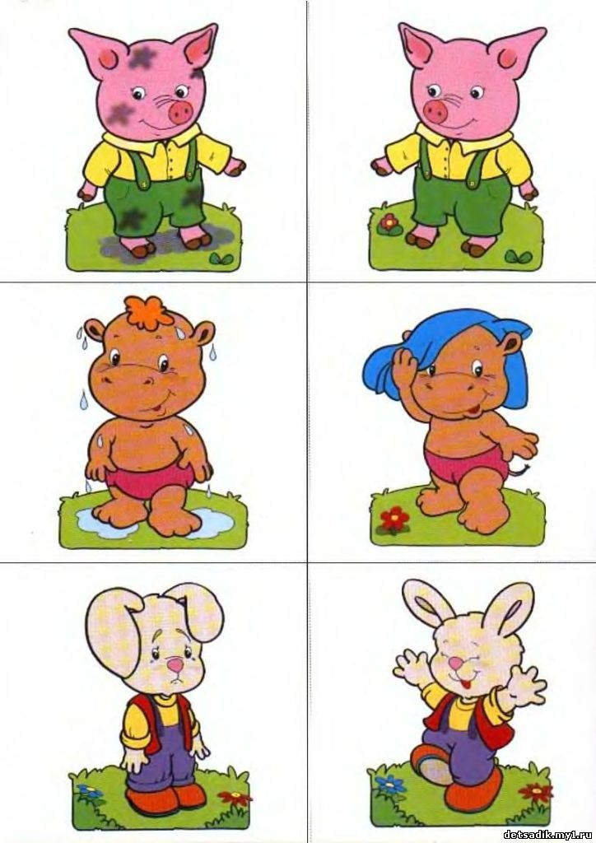
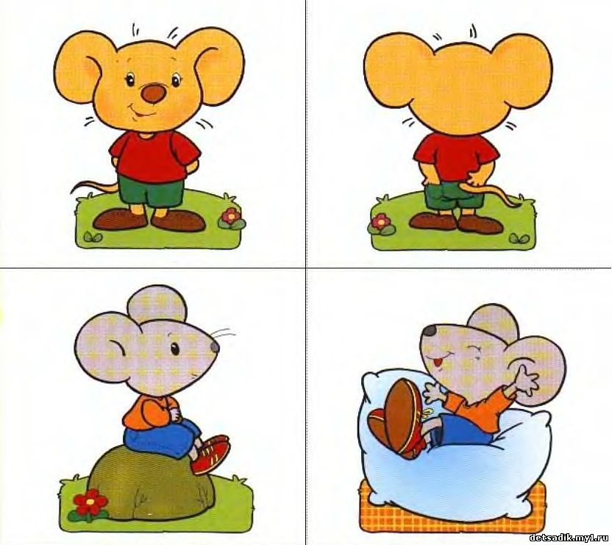

Handout for activity 3

м/ф «Бременские музыканты»

Слова Ю. Энтина,
музыка Ген. Гладкова

Ничего на свете лучше нету,
Чем бродить __________ (друзьям) по белу свету.
Тем, кто дружен, не страшны тревоги,
Нам любые дороги ___________ (дороги).

Наш ковер — цветочная поляна.
Наши _______ (стены) — сосны великаны.
Наша крыша — небо голубое,
Наше ________ (счастье) — жить такой судьбою.

Мы свое призванье _________ (не забудем):
Смех и радость мы приносим людям.
Нам _________ (дворцов) заманчивые своды
Не заменят никогда свободы!

