Conversation Class Lesson Summary

Language Resident Name: Akihiro Shimizu

Day and Date: 3/2, Monday

Language and Level (intermediate or advanced class): Japanese, Intermediate

Class theme/topics discussed: Haircut and conversation project

Goal of the class:
Students will learn vocabularies of haircut
Students will know how to get hair cut

How did you structure the class?
1. Confirmation
I announce that I will do feedback session next class. And I notice students that they may receive a low-grade notification.
2. Warm-up
I ask students how often they get their hair cut. Where are you get your hair cut?
3. Vocabularies
I distribute a copy of handout. We go through vocabularies used in beauty salon or barber. I explain them using whiteboard if necessary.
4. Hairstyle
We check pictures of hairstyle. How are they called in Japan?
5. Expression
Students learn typical expressions often used in beauty salon. They match these expressions with 4 scenes in salon.

What technology, media or props did you use? (internet resources, playmobiles, handouts, etc.)
Handout, Whiteboard

What worked well in this class? What did not work?
The US is not as homogeneous as Japan. And hair type is diverse. that makes class a little bit sensitive.

How could this class be improved/ modified?

If you have a more detailed lesson plan, please attach it below (OK to use target language for that). Please attach any handouts as well.

- ボキャブラリー
美容室（院）、床屋、散髪、顔そり、髪型、すく、バリカン、クセ（毛）、（天然）パーマ、ストパー、染める

- 髪型
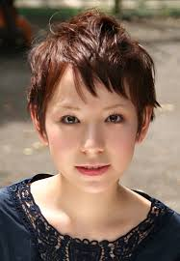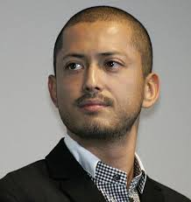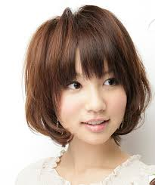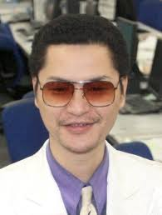
（ ） （ ） （ ） （ ）
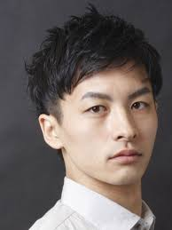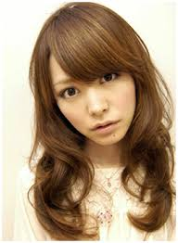
（ ） （ ）

３ 表現
シーン1 シーン2 シーン3 シーン4
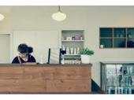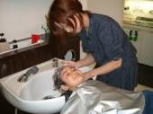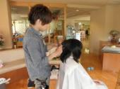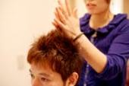

（ ） （ ） （ ） （ ）

A.いらっしゃいませせ、B.何かつけますか、C.今日はどんな感じしましょうか、D.熱くないですか、E.かゆいところがあったら言ってください、F.お会計は3500円です、G.お仕事は何をされてるんですか、H.苦しくないですか

