Conversation Class Lesson Summary

Language Resident Name: Akihiro Shimizu

Day and Date: Monday, February 23th, Tuesday, February 24th.

Language and Level (intermediate or advanced class): Japanese, Intermediate and Advanced

Class theme/topics discussed: Mail Service

Goal of the class:
Students will learn vocabularies in post office.
Students will be familiar with the system of mail service in Japan.

How did you structure the class?
1. Warm-up
I ask students if they have sent a mail in Japan? How was that? What was difficult?
2. Vocabularies
I distribute a copy of handout to students. We confirm the vocabularies and expressions of postal service on it. I add some explanation. The vocabularies are found in 『日本語集中トレーニング』p65.
3. Skit
A student makes a skit with his/her partner that matches the pictures on the copy. Each picture shows a scene in postal office. Each pair comes up with conversations for each scene. Then, The students demonstrate what they made. The pictures are found in 『日本語集中トレーニング』 p64-65.
4. Map
I draw a picture on white board that shows inside of a post office. I ask students where they should go first when they get to the office. We confirm the procedure they go though to send a package.
5. Explanation
I distribute a copy of handout. I explain fees to send a card, envelop or package.
6. How to write?
With pictures of post cards and envelope, we confirm how to write our address and that of a receiver on them. Should they be vertically written or horizontal? Where do we write them?

What technology, media or props did you use? (internet resources, playmobiles, handouts, etc.)
Handouts, whiteboard

What worked well in this class? What did not work?
It worked well. The way to write names and addresses on a post card is different form American one. So they got surprised!

How could this class be improved/ modified?

If you have a more detailed lesson plan, please attach it below (OK to use target language for that). Please attach any handouts as well.

郵便

料金 はがき52円 普通郵便82円（25kg以内）ゆうぱっく1000円くらい

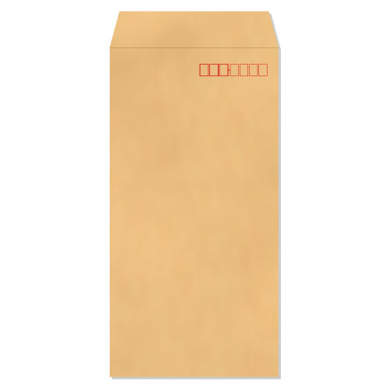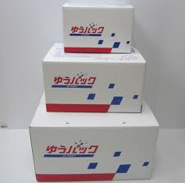

郵便を送りましょう
あなたの住所 東京都千代田区富士見2-17-1〒102-8160
あなたの電話番号 090-xxxx-1934
相手の住所 東京都八王子市北野町32-3
相手の電話番号 xxx-323-xxxx
送るもの 本

日付 10月31日

