Conversation Class
Lesson Summary

Language and Section:
French 13 ADV

Date:
10/17/13

Class theme/topics discussed: Driving

Goal of the class: Talking about driving and the driving license

Structure of the class (unless you attach your lesson plan below):

Vocabulary about the car: 10 min

- Pair work. I give them a schema of a car and a list of words to place correctly.

General discussion: 10 min

- We just talk about how is the driving license in France: time, cost, “conduite accompagnée”, how is the exam, etc. We compare it with the American system.

Street signs: 10 min
- Goal : make them guess the meaning of some French street signs
- Groups of 3 students. I give them a paper with different street signs. They have to guess what does it means.
- Five minutes later, I give them more information, like a list of meanings and they have to match the sign and the definition.

Brainstorming: 10 min
- Goal: making a list of the all the offenses you could do while driving. How should we behave while driving? Learn new vocabulary.
- With all the class.
- NOTE: As two students in particular are too much talkative, try to moderate the exercise by giving speech only to those who raise their hands.
- Did they already have a car accident or make an offense?

Pair-work: 20 min
- Goal: make them create a story and a dialogue based on a context.
- I give them some situations (policeman, driver)
- Two to three turns.

What technology, media or props did you use? (satellite tv, internet resources, playmobiles, etc.)

What worked well in this class? What did not work?
They were interested in the French driving license and I had no idea it was this complicated and expensive.

How could this class be improved/ modified?

Please attach your lesson plan and handouts for this class below – if you used any.

Next page : handouts

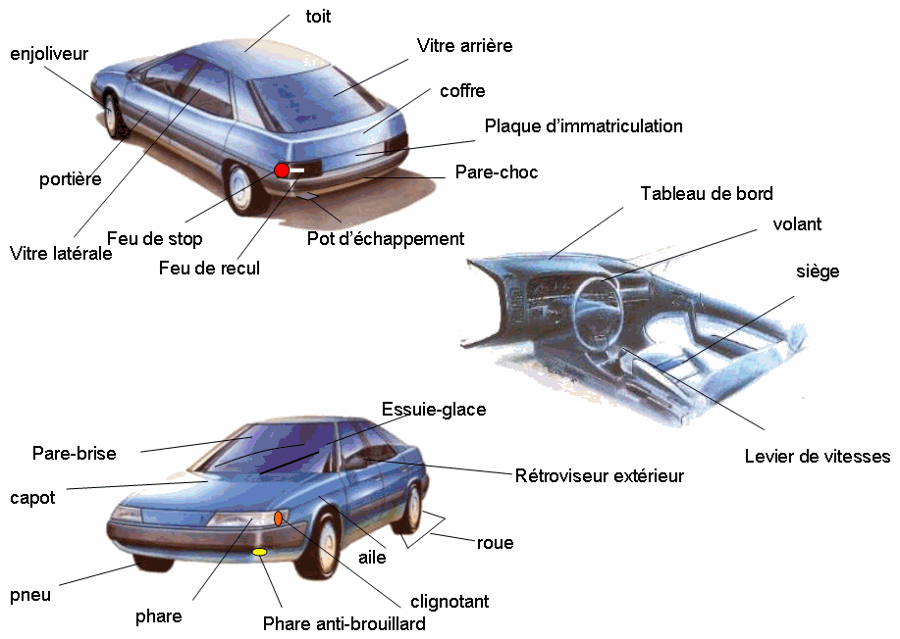

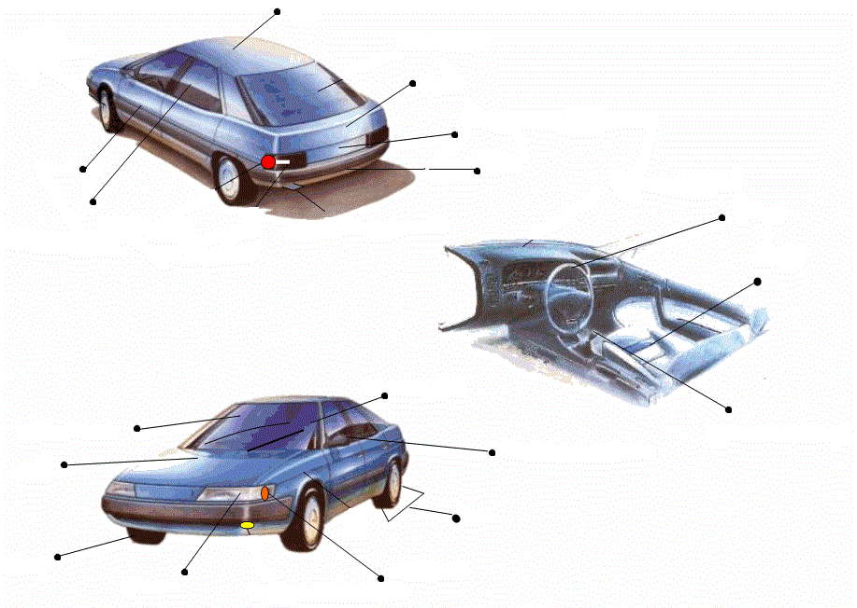
Vocabulaire à placer
- Une portière
- Un pare-brise
- Un capot
- Un pneu
- Un clignotant
- Une roue
- Un phare
- Le toit
- Une plaque d’immatriculation
- Un siège
- Un volant
- Le levier de vitesse
- Un essuie-glace
- Un rétroviseur
- Le coffre
- Un pare-choc
- Une vitre

Les panneaux triangulaires annoncent un danger.
Les panneaux ronds annoncent une limitation, une interdiction.
Les panneaux bleus annoncent une obligation.

Sens interdit : on n’a pas le droit de passer par là

Limitation à 50 km/h : on n’a pas le droit d’aller plus vite

Interdiction de stationner : on n’a pas le droit de se garer

Impasse : cette rue est sans issue

Attention, passage de piétons

Attention, feux tricolores à proximité

Obligation de tourner à droite

Attention, succession de virages

Vous faites un excès de vitesse, un gendarme vous arrête. Vous lui expliquez que votre femme est sur le point d’accoucher mais il ne vous croit pas.

Un gendarme vous arrête. Il veut à tout prix vous trouver une infraction, mais vous êtes irréprochable.

Un gendarme vous arrête pour avoir téléphoné au volant. Vous vous faites passer pour quelqu’un de très important, mais le gendarme est suspicieux (il a du mal à vous croire).

